## The Flush Median Tool

This tool works like any Polygon where you click to place each of its corners and can adjust the control points to get the shape you need.

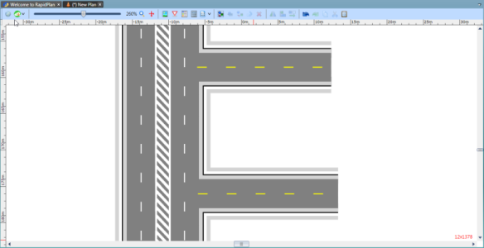

A_Flush_Median_tool